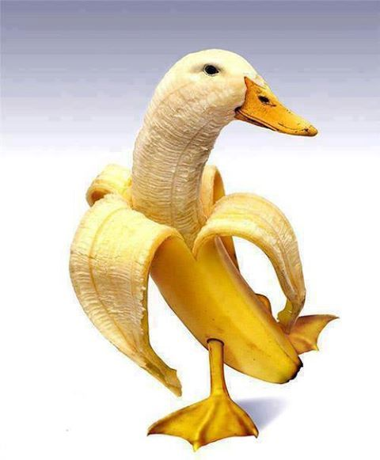

Duckana is excited about Mix-it-Up
@Lunch Day.
Tues, Oct 25th

