CHESTNUT HILL COMMUNITY SCHOOL
59 State Street
Belchertown, MA 0l007
www.belchertownps.org
413.323.0437 FAX 413.323.0459
November 17, 2015
Dear CHCS Parents & Guardians,
This holiday season students are being asked to help collect non-perishable food items (i.e., canned meats, fruits, vegetables, dry goods such as mixes, pasta, cereal, canned juices and beverages, instant meals, etc.), art/school supplies (pencils, pens, crayons, markers, notebooks, art pads, folders, rulers, erasers, etc.), books (for gr. 4th-6th) and arts & crafts or hobby kits for those in need. Donations will be collected in the CHCS lobby throughout the month of December. (Please remember to check expiration dates on the food items.) This act of kindness is a form of Helping Others; one of the most important values in our PeaceBuilders Pledge. Please talk with your child about this and assist them in helping meet the needs of others.

If you have any questions or concerns regarding this event, please contact the Counseling Department‎.

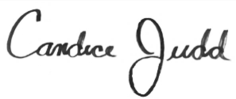
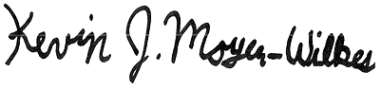
Sincerely,
&

Candice Judd & Kevin J. Moyer-Wilkes
Chestnut Hill Community School Counselors

CHESTNUT HILL COMMUNITY SCHOOL
59 State Street
Belchertown, MA 0l007
www.belchertownps.org
413.323.0437 FAX 413.323.0459
November 17, 2015
Dear CHCS Parents & Guardians,
This holiday season students are being asked to help collect non-perishable food items (i.e., canned meats, fruits, vegetables, dry goods such as mixes, pasta, cereal, canned juices and beverages, instant meals, etc.), art/school supplies (pencils, pens, crayons, markers, notebooks, art pads, folders, rulers, erasers, etc.), books (for gr. 4th-6th) and arts & crafts or hobby kits for those in need. Donations will be collected in the CHCS lobby throughout the month of December. (Please remember to check expiration dates on the food items.) This act of kindness is a form of Helping Others; one of the most important values in our PeaceBuilders Pledge. Please talk with your child about this and assist them in helping meet the needs of others.

If you have any questions or concerns regarding this event, please contact the Counseling Department‎.

Sincerely,
&

Candice Judd & Kevin J. Moyer-Wilkes
Chestnut Hill Community School Counselors

