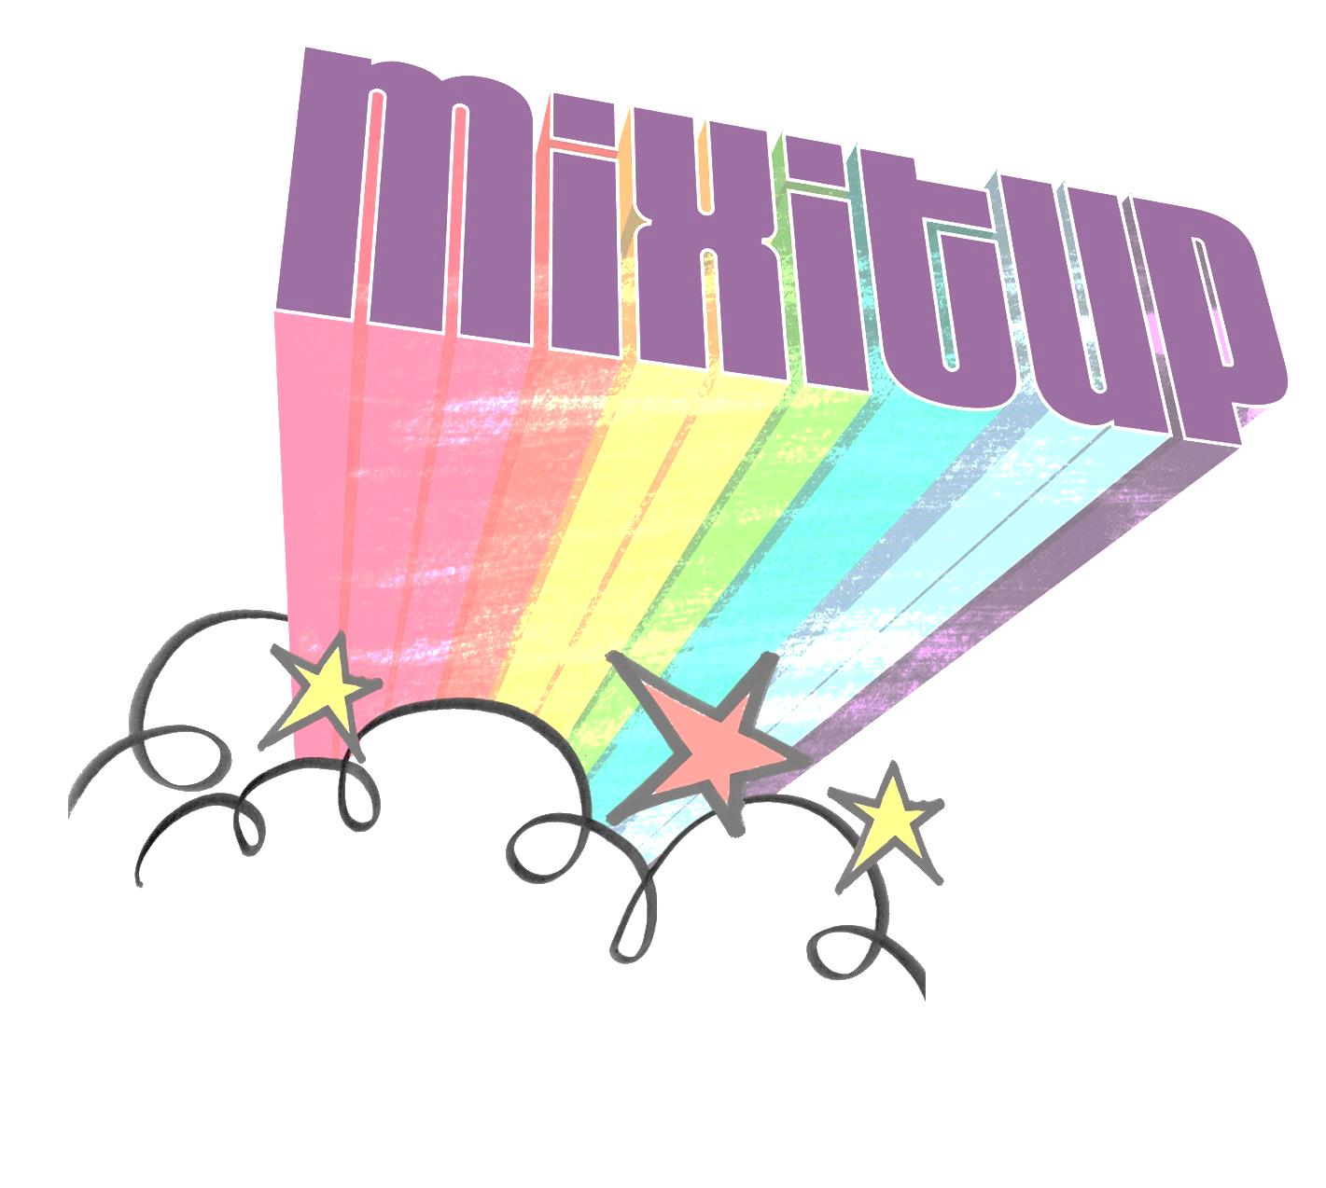
What happened when you mixed it up?

1. ) Who did you meet on Mix-it-Up Day? (first names only)

2. ) What did you talk about?

3. ) What did you learn from your experiences on Mix-it-Up Day?

